**Greenhouse Gas Cost of Beef Restaurant Menu Options**

**DATA**

The most popular sandwich at a leading fast food restaurant contains 211g (7.4 oz) of beef. Consumers of this sandwich may not know that they are also purchasing a Greenhouse Gas Emissions unit equal to driving a car almost 9.81 miles (7.40 pounds of CO2-equivalent emissions from producing half a pound of beef – link: [How Meat Contributes to Global Warming - Scientific American](https://www.scientificamerican.com/slideshow/the-greenhouse-hamburger/)). An informative publication by the NRDC tells us that beef “contributes more climate-warming pollution than any other food in the American diet.” (link: <https://www.nrdc.org/sites/default/files/less-beef-less-carbon-ip.pdf>

Restaurant menu data sources will include Foursquare and other published datasets (including [Nutrition Facts for McDonald's Menu | Kaggle](https://www.kaggle.com/mcdonalds/nutrition-facts) ). After gathering this data, I plan to utilize the EPA’s Greenhouse Gas Equivalencies Calculator (link: <https://www.epa.gov/energy/greenhouse-gas-equivalencies-calculator>) to measure the Greenhouse Gas Cost of each menu. From this, I will be able to use Foursquare location data to provide a visual representation of the Greenhouse Gas Costs of a location’s retail food establishments.

**Greenhouse Gas Cost Calculation**

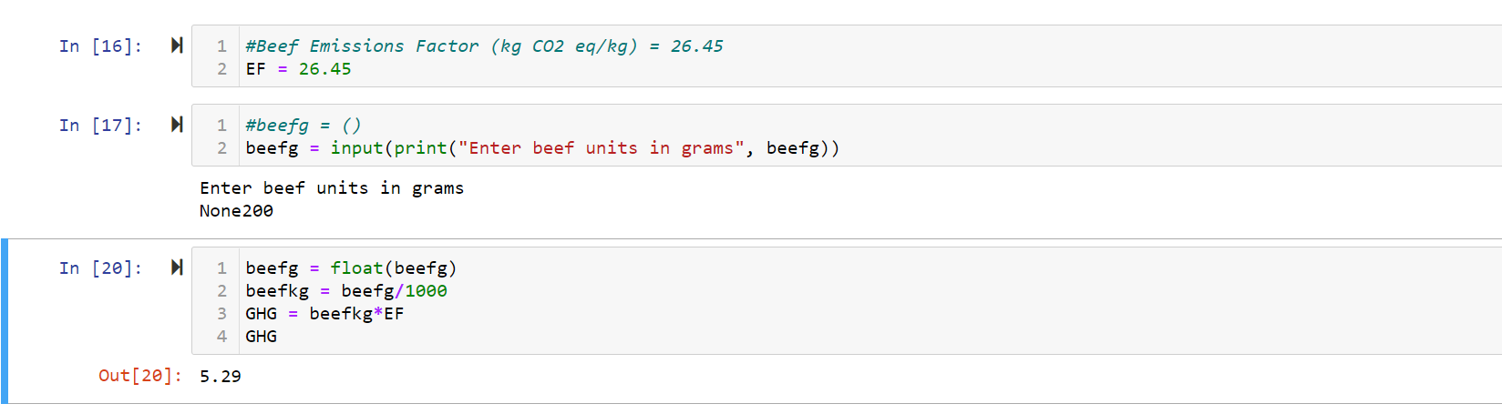

**Foursquare Restaurant Menu Data**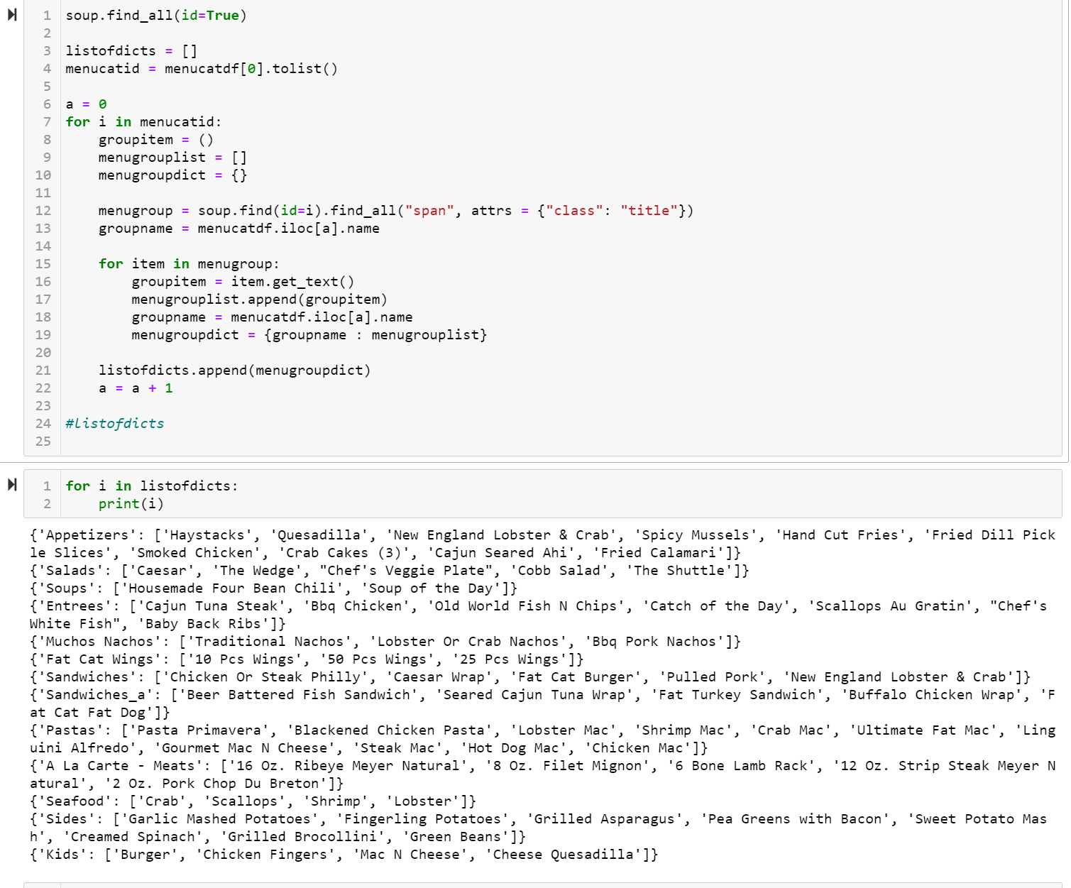

**McDonald’s Restaurant Menu Data**

